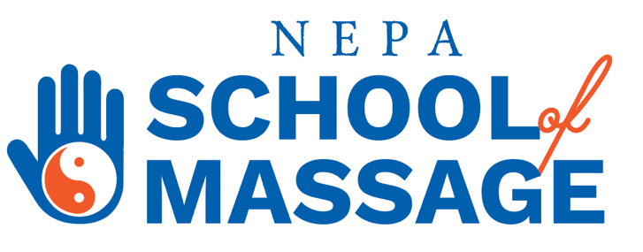

NEPA School of Massage Institutional Grants

NEPA School of Massage High School Graduate 2022-2023 Institutional Grant

The purpose of the NEPA School of Massage Institutional Grant for a High School Graduate of 2022-2023 is to provide supplemental financial assistance to a high school graduate of Luzerne or Lackawanna County, Pennsylvania.

Applicant must:
- Fill out the Grant application.
- Provide their High School Transcript.
- Write an essay about who they are and their plans for the future.
- Come for an in-person interview.
- Provide two letters of recommendation by a non-family member.

Applicant will receive $1,500.00 granted towards tuition.

NEPA School of Massage Institutional Grant

The purpose of the NEPA School of Massage Institutional Grant is to provide supplemental financial assistance to an individual residing in Luzerne or Lackawanna County, Pennsylvania.

Applicant must:
- Fill out the Grant application.
- Provide their proof of living.
- Write an essay about who they are and their plans for the future.
- Come for an in-person interview.
- Provide two letters of recommendation by a non-family member.

Applicant will receive $1,500.00 granted towards tuition.

